**Project Two**

**Programming with Matplotlib**

***Objectives of this lab:***

* Use pip to install python packages.
* Use the matplotlib module and submodules for graphing.
* Create bar graphs, line graphs, and pie charts.

Project Name: Project 2

Group Members: **ADIT GAUTAM SOLO**

Project Description: Python with Matplotlib library

Date: 1.28.2025

**Section 3.23 in Zybooks** introduces the topic of plotting simple graphs. In this section you will find the necessary tools that will help you with this project. **You will need to read this section**.

**Part One: Bar Charts**

**__________________________________________**

**Exercise 1.1**: Create a simple bar graph.

CONTINUED BELOW

**Include a Copy/Paste your code here (with header and documentation):**

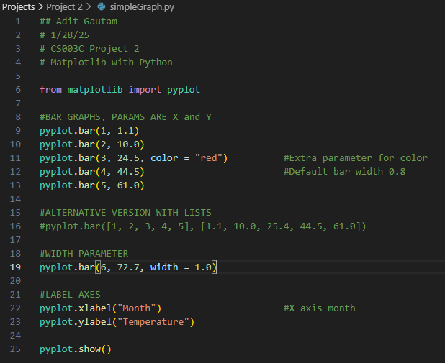

**Include a full screenshot of your execution here:**

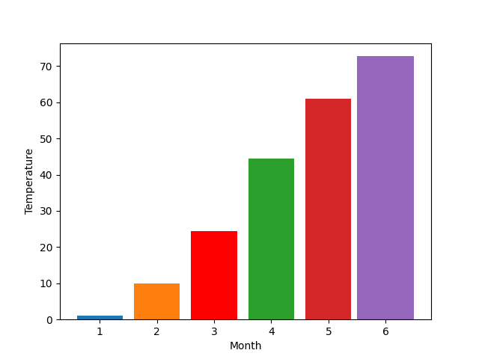

**Exercise 1.2**

Suppose you have been offered a job in beautiful Fairbanks, Alaska, and you are considering whether to accept. Perhaps you are concerned about the climate. This is how warm it gets on average each month:

Open a file called **Fairbanks.py**:

Create a variable for each month and assign a value for the temperature according to the chart above:

*january = 1.1*

Plot the temperature for each month.

*pyplot.bar(1, january)*

Draw a line across the graph for 32 degrees Fahrenheit:

*pyplot.plot([0, 14], [32, 32], "--")*

Format the graph (**refer to table 3.23.2: Plotting Functions in Zybooks**) and display it.

* Add a title.
* Add x-label and y-label.
* Add x-ticks.

**Include a Copy/Paste your code here (with header and documentation):**

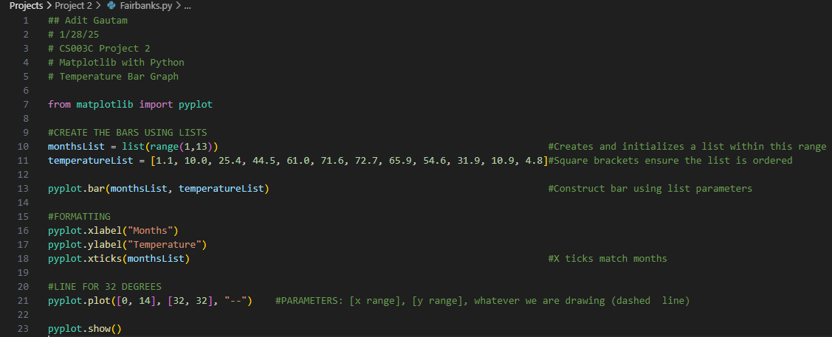

**Include a full screenshot of your execution here:**

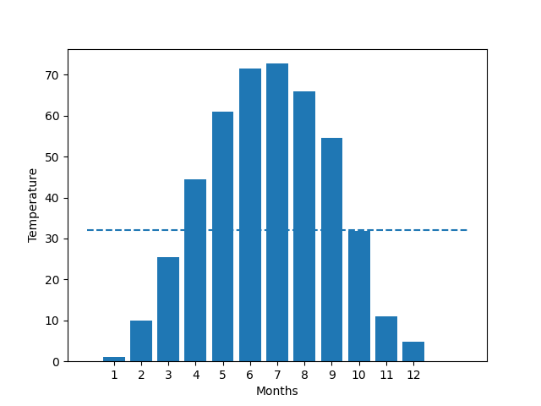

**Part Two: Line Graphs**

**Exercise 2.1**

We will use the following sales data for two products (Product A and Product B):

Write a program called **productSalesComparison.py** that compares the sales of product A and product B using line graphs (2 lines).

Refer to 3.23 **Create a Line Graph** in Zybooks. You can also use table 3.23.1 for extra color codes, line styles, and marker types.

Your line graph should include the following:

* 3 sets of data (months, product A sales, product B sales)
* For example: *months = ['January', 'February', 'March', 'April', 'May', 'June']*
* Each line should have a marker, color, label.
* A title 🡪Sales Comparison of Product A and Product B
* x-label 🡪 Months
* y-label 🡪Sales
* y limit from 0-800
* a grid
* a legend
* show the graph

Sample Output:

**Include a Copy/Paste your code here (with header and documentation):**

**I did this with classes. Not sure if that’s allowed.**

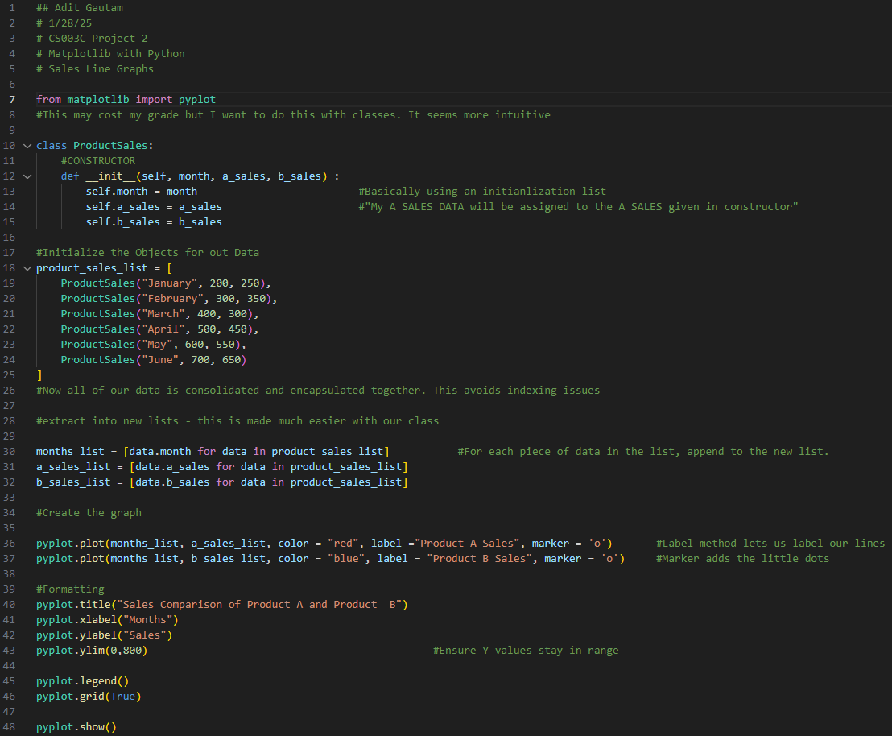

**Include a full screenshot of your execution here:**

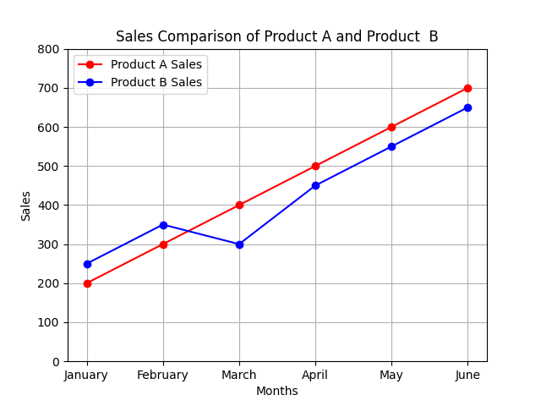

**Part Three: Pie Charts**

**Exercise 3.1**

The pie command in the pyplot module draws a pie chart. You supply a list of the values. Write a program called **ContinentPieChart.py** that draws a pie chart of the areas of all continents.

Your Pie chart should include the following:

* 2 sets of data (continents, areas)
* For example:
* *areas = [30.37, 14.00, 44.58, 10.18, 24.71, 7.69, 17.84] # Areas in million km²*
* when using pie command, you should designate the labels as the continents, and use format specifier: autopct='%1.1f%%’ and a start angle = 140
* A title 🡪Pie Chart of the Areas of Continents
* Add an axis command set to ‘equal’ to ensure pie chart is drawn as a circle.
* Show the pie chart.

**Include a Copy/Paste your code here (with header and documentation):**

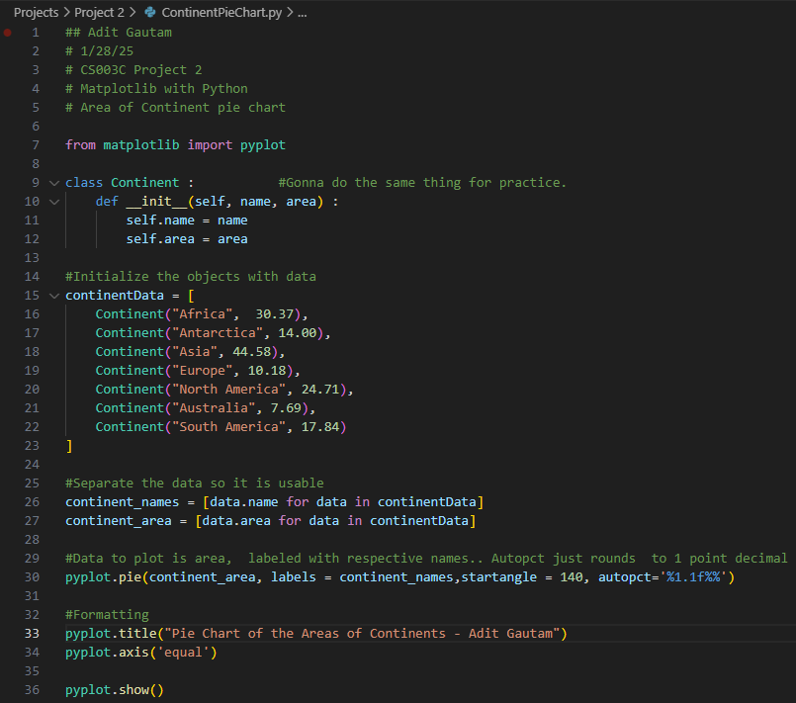

**Include a full screenshot of your execution here:**

